|  |  |
| --- | --- |
| **Name** | **Enayathulla A** |
| **Date** | **02.01.2024** |
| **Type** | **Daily Assignment** |
| **Topic** | **Creating Delta Lake Table** |

**Creating Databricks:**

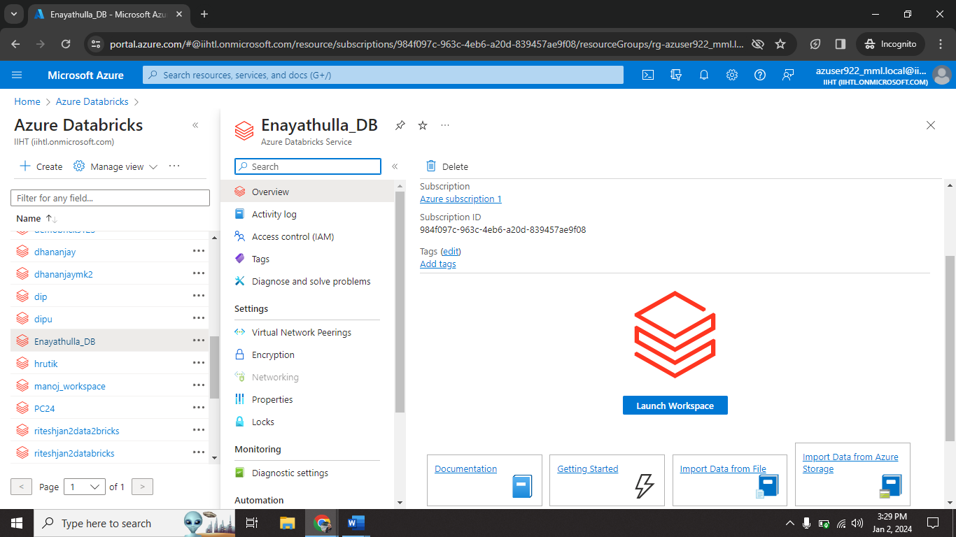

I created one azure databricks (Enayathulla_DB) resource.

**Creating Cluster:**

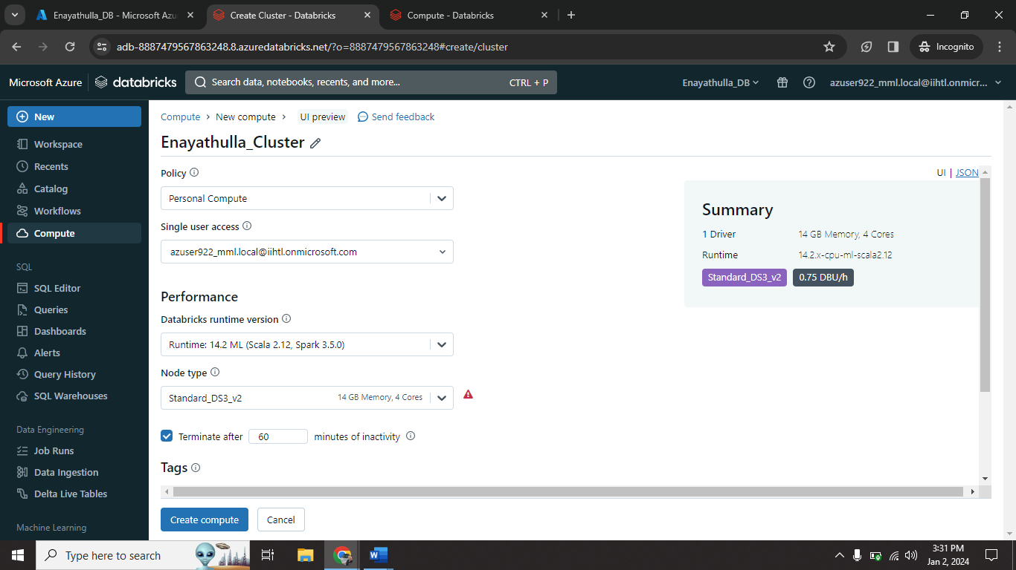

I created one cluster (Enayathulla_Cluster) on Enayathulla_DB resource.

**Creating NoteBook:**

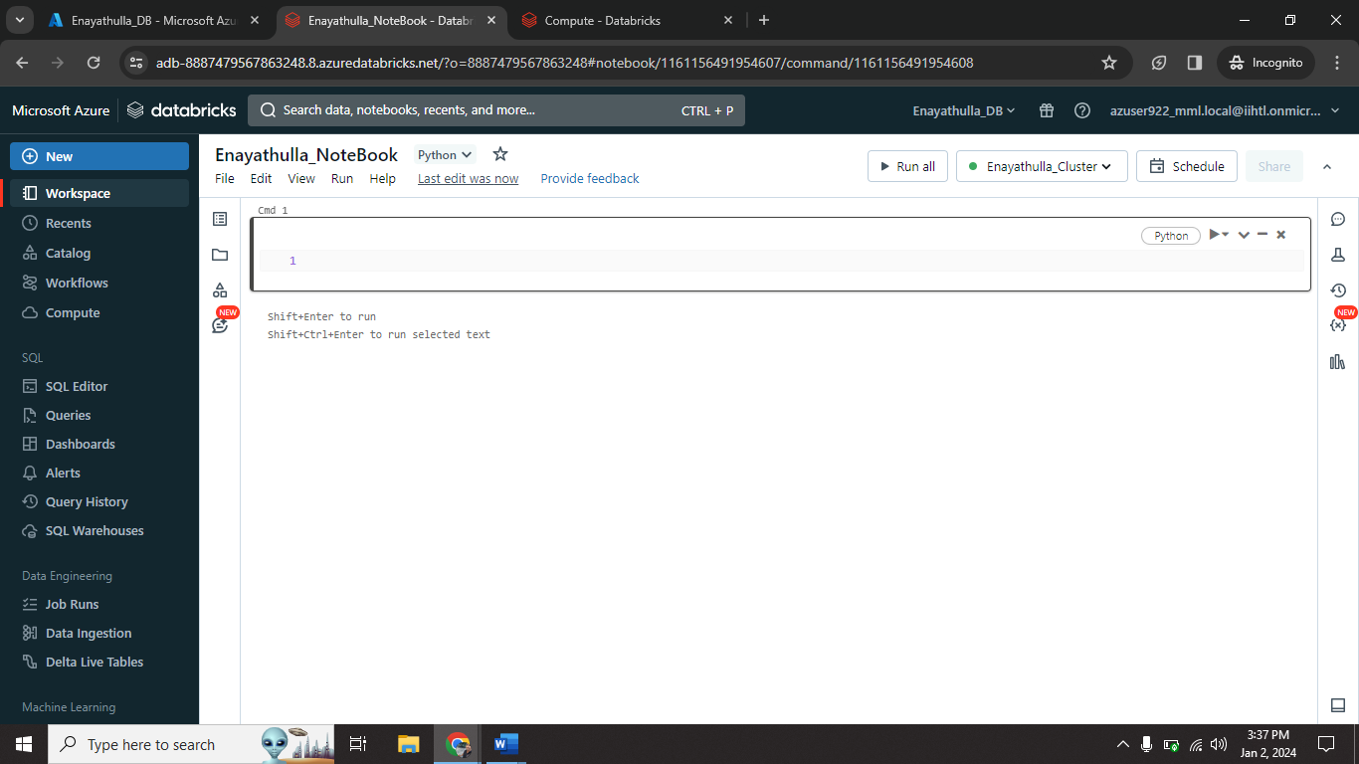

I created one NoteBook (Enayathulla_NoteBook) on Enayathulla_Cluster.

**Execute some sample code:**

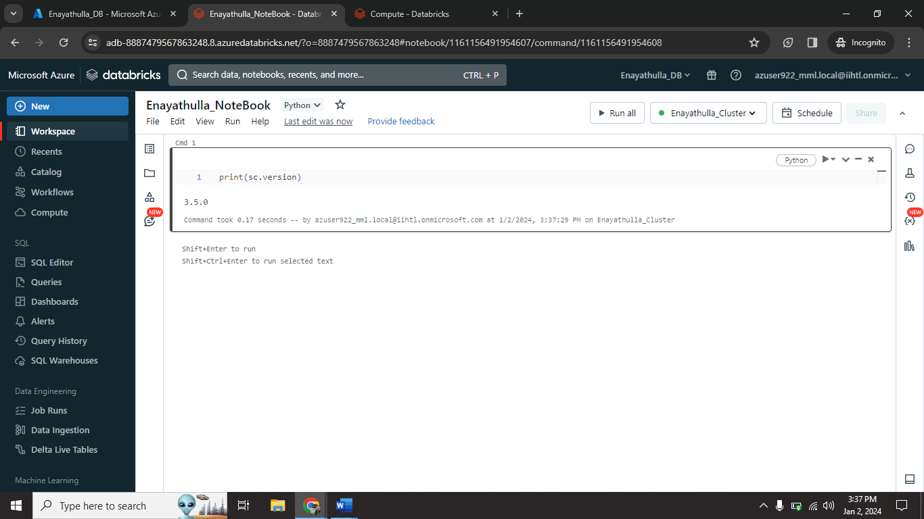

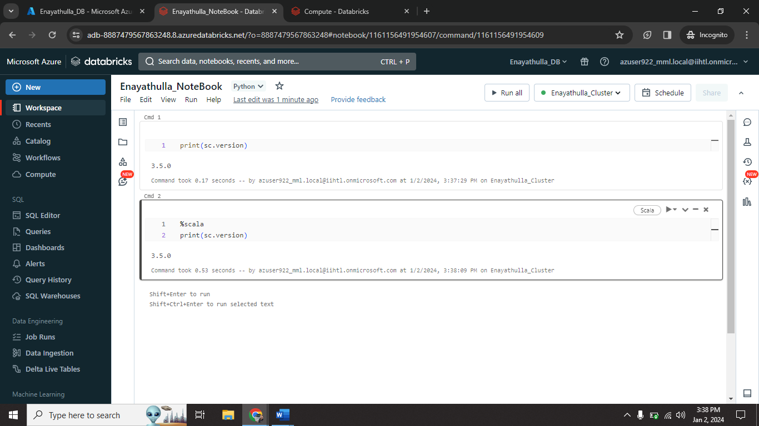

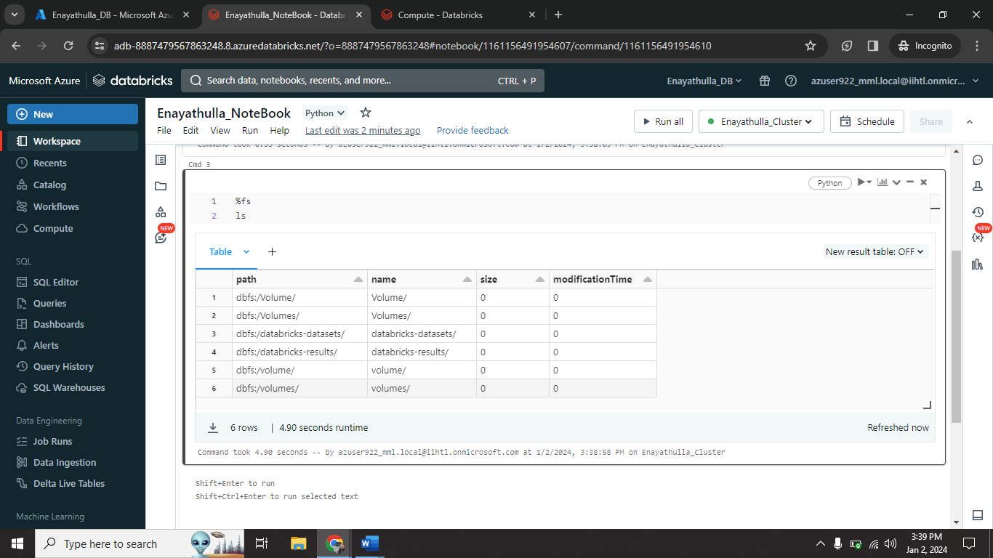

I ran some sample codes on notebook.

**Upload Local file into Databricks:**

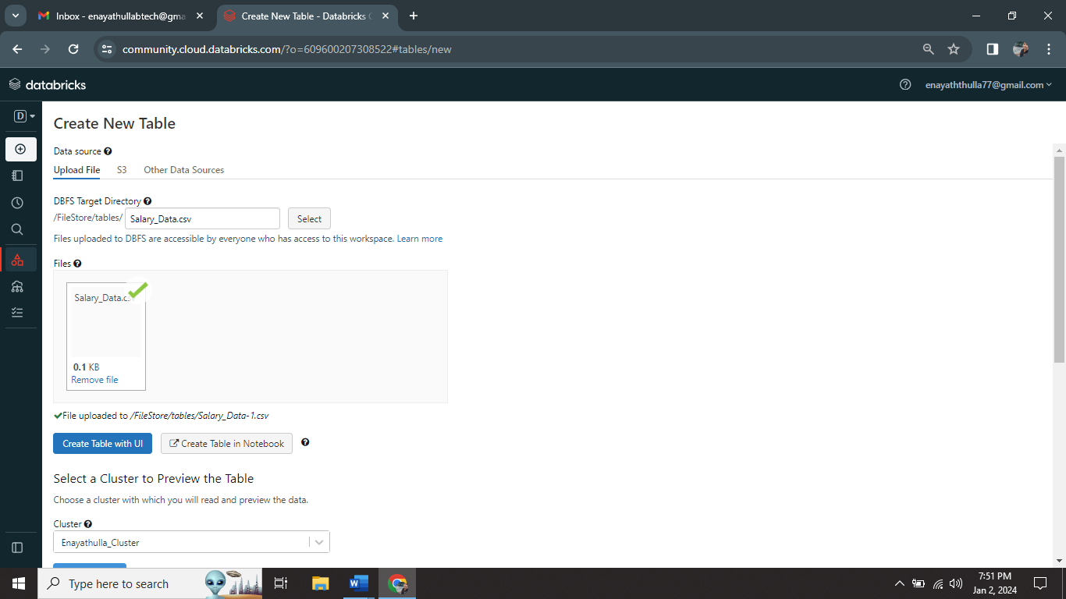

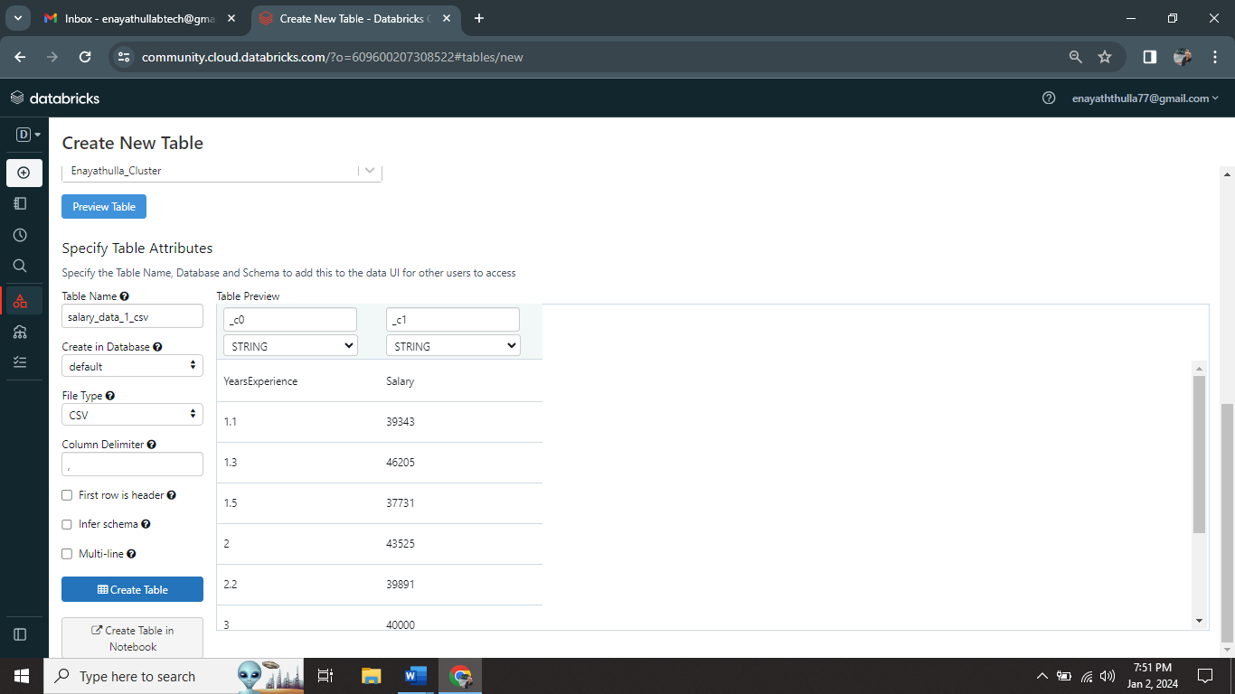

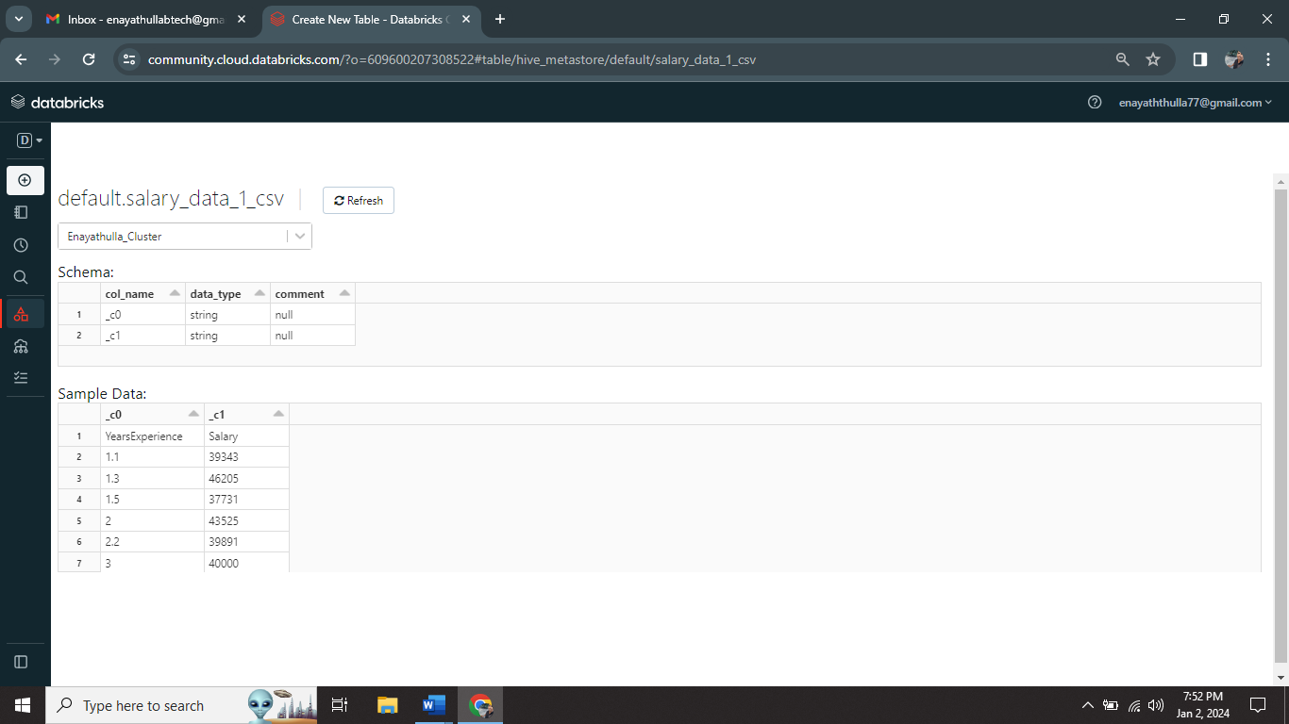

I successfully uploaded csv file into databricks as Table.

**Performing Tasks with CSV file as Table:**

